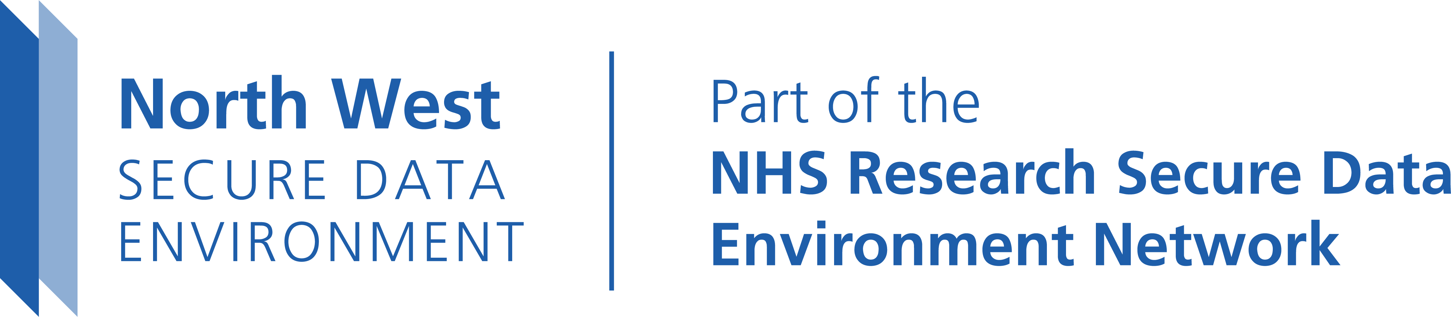
NHS North West Secure Data Environment
Data Accelerator Fund for Novel and Emerging Assets (DAFNEA)
Application Form
Please complete the following application form in no more than 8 pages (excluding the permitted annexes such as data specification, Gantt chart, data controller letter of support and project partner statements of support). Minimum font size of 11 points for the main. Margins should be at least 2cm, and single line spacing is required.
Section 1: Applicant details
Title of data asset:
Lead applicant (name, email):
Organisation of lead applicant:
Collaborating partners [insert rows as needed if multiple] | Email | Institution
Legal signatory of data asset: | Email | Institution
Provide name and contact email of the Caldicott Guardian for the data controller : | Email | Institution
Section 2: Plain language summary
Provide a clear, accessible overview of the data asset for a public audience and a statement of your ambition for it. (maximum 250 words). Include: who the data relates to, what information it contains, and the potential benefits of research using this asset. If your application is successful, this summary will be featured in public-facing materials, including the North West SDE website. Use plain language, avoid technical jargon and cliche, and focus on why the dataset matters for improving health and care.

Section 3: Data asset overview
Consented data (yes/no)
Modes of data (e.g. imaging, genomics, PROMs)
Service areas covered (e.g. hospital, mental health, maternity, housing)
Source system(s) or platform(s)
How will the data be shared with the North West SDE? e.g. direct from software provider, from local server, from a CSV or Excel file?
Describe the evidence for your data being able to be shared for research – e.g. has been done before, already extracted from the host system into server or CSV file, already shared for other secondary purposes.
Will the data be hosted locally or is the project seeking ongoing data hosting with the North West SDE?
Geographical coverage of the asset
Number of potential unique individuals included
Start and end date of data collection (or indicate if ‘ongoing’)
If ongoing, please outline how the data collection is funded, and expected annual increase in the data asset.
List personal identifiers within the data (NHS no., name, DOB, other) to enable linkage
Provide a brief description of the data asset, including an assessment of its quality (maximum 500 words).
If you have a dataset specification and or meta-data schema (description) please attach it to your application.
Your summary should explain:
- How the data was collected, including relevant context.
- Structure and content, such as available tables and key variables (high level summary)
- Population details, with a breakdown by key characteristics where possible (e.g., age, sex, ethnicity, geography).
For the data quality assessment, address:
- Completeness: Are expected fields present? What proportion of values are missing?
- Accuracy: Does the data reflect real-world values?
- Consistency: Are formats and coding standards applied uniformly?
- Validity: Do values fall within expected ranges and align with recognised standards?
- Uniqueness: Are unique identifiers used and duplicates removed?
Write clearly and concisely, avoiding technical jargon where possible.

Section 4: Merit of the data asset

What gap does this asset fill in the healthcare data ecosystem (maximum 250 words)?
Explain the unique contribution of your dataset by addressing:
- Unmet needs: Describe the specific healthcare, research, or policy questions that cannot be answered with current data.
- Added value: Highlight how your asset provides new insights, improves linkage opportunities, or supports multimodal/deep data analysis.
- Impact potential: Show how filling this gap will benefit public health, clinical decision-making, or innovation.

Describe the potential public benefit and/or commercial value (maximum 250 words).
For example, for public benefit, explain how the dataset will improve health outcomes, patient care, or service delivery; highlight benefits for specific populations or communities (e.g., reducing health inequalities, supporting preventive care); and describe how research enabled by this asset could inform policy, clinical guidelines, or innovation in healthcare.
For commercial value; identify opportunities for partnerships with industry, technology providers, or life sciences; explain how the dataset could support product development, digital health tools, or commercial research; and emphasize potential for economic impact, such as cost savings or efficiency gains.

Can you provide evidence for public benefit, with or without commercial potential, where possible providing evidence of collaboration or engagement with research or commercial partners (maximum 300 words)?
Please list ongoing or completed projects with research or commercial partners using the data asset, including grant applications or project ideas. If available share examples of other research groups creating similar data assets. Where possible cite outputs from similar or related work including academic papers, articles, press releases, reports etc. (max 300 words)

Please describe any prior engagement with patients and/or the public to use this data asset for research, or how you plan to do this if not already done (maximum 250 words).
This can include initial workshops to develop the asset, inclusion of patient representatives in the programme, and specific outreach events to discuss the utility of the data asset.

Section 5: Project plan
Please provide a plan of how you will deliver a signed data sharing agreement by 31st March 2026 (maximum 300 words)
Please provide clear step-by-step process, with a clear review cycle before the organisational signing of the data sharing agreement. Please highlight any risks to the delivery of the DSA, and highlight any mitigation measures you have put in place.

Please provide a plan of how you will deliver the technical infrastructure and metadata to share data with the North West SDE by 31st December 2026 (maximum 300 words)
What the steps, who needs to approve the process, which people/departments in involved, what resource is needed. Please highlight any risks to the delivery of the technical infrastructure and metadata, and highlight any mitigation measures you have put in place.

Please provide details of proposed patient, public and professional engagement during the project (maximum 250 words).

Describe the three most significant delivery risks under your control, and your proposed mitigations (maximum 300 words).
Risk one:
Risk two:
Risk three:
Section 6: Costings
Funding amount
Justification of funding amount (maximum 250 words)

Costing
Summary Fund Heading | Fund Heading | Full Economic Cost  (100% fEC) | North West SDE Contribution Requested (Direct only)
Directly Incurred | Staff
Directly Incurred | Travel and Subsistence
Directly Incurred | Consumables
Directly Incurred | Equipment
Directly Incurred | Other Costs
Total

Partner contributions (in-kind and cash) (add rows if necessary)
Organisation | Description of contribution(s) | In Kind value (£) | Cash value (£)

Finance Contact in Lead Organisation
Name: | Role:
Email: | Tel:
Approval from finance team to apply to this funding opportunity | Yes / No
8 page limit (permitted annexes to follow)

